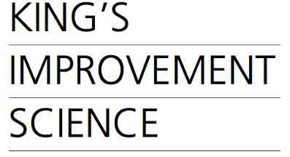

King’s Improvement Science (KIS) Partnership Steering Group
Diversity Monitoring Form (Optional)
If you provide this information, we will use it to analyse which groups of people are interested in working with us, so that we can think about how we work in the most accessible way possible. The information will be combined with other applicants’ information and kept anonymously in a spreadsheet until the end of the current KIS funding grant in 2024, so that we can monitor whether this changes over time. Once the data is combined we will delete your individual submission.
Please email this information, either as the completed form or in audio or video format, to kis_involvement@kcl.ac.uk.

Age group (you can leave this question blank if you want): (delete or highlight as appropriate)

18-24 / 25-29 / 30-39 / 40-49 / 50-59 / 60-69 / 70-79 / 80+

How would you describe your gender (you can leave this question blank if you want):

How would you describe your sexuality (you can leave this question blank if you want):

How would you describe your racial or ethnic background? (you can leave this question blank if you want):

Do you have any disabilities and is there anything we could have offered to make the application process more accessible to you? (you can leave this question blank if you want):

